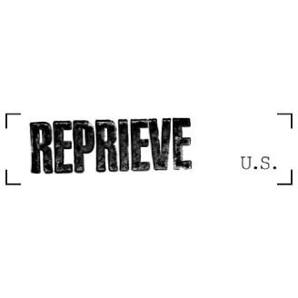

APPLICATION FORM
PLEASE RETURN BY 11:59 EST on 17 November 2024 to Applications@reprieve.org.uk

Please note: Reprieve US does not ask for some specific details (for example the school you attended) to promote a fair recruitment process. Please read all questions carefully, and only provide the information asked for.

Name:
Role applied for: | Head of Death Penalty Projects- USA

Employment or volunteering history – in chronological order with the most recent first. Please add additional pages as necessary

Dates to and from | Employer / Organisation | Job title and main duties/responsibilities

HOW YOU FULFIL THE KEY CRITERIA
Please answer each section with no more than 100 words.

Please give examples on how you think you satisfy
each of the ESSENTIAL CRITERIA below in turn:

- Proven ability to juggle multiple and competing tasks in a high-pressured environment
- Experience of forming and maintaining effective working relationships with business people, lawyers, experts or other professionals and organizations, along with the ability to work constructively and sensitively with individuals from different cultures and backgrounds

- Ability to give clear and appropriate instructions and guidance to those under your supervision
- Familiarity with legal and policy matters relating the death penalty

- Ability to think strategically and consider both legal and non-legal avenues to benefit those we assist and affect change on a wider level

- Juris Doctor (J.D.) degree and significant experience leading litigation or other legal work

DESIRABLE CRITERIA

Please say if and how you meet any of the desirable criteria below (in no more than 300 words), giving examples where possible, including any transferable skills relevant to the post you are applying for.

If a qualification is required for a role, it is Reprieve US’ policy to verify the qualifications of the successful applicant. You may be asked for your consent for these checks at a later stage in the process.

STATEMENT IN SUPPORT OF APPLICATION

Please provide any further, relevant information in support of your application (maximum 500 words)

TO BE DETACHED PRIOR TO SHORTLISTING

Personal details

Last name:
First name:
Current address:
Telephone number:
Email:

Other details
What is the notice period required in your present job?
Is your current role your sole regular employment? | Yes/No
Do you have the right to work in the US currently for the duration and hours of the role you are applying for?

Where did you see the advertisement for the job?
Reprieve US is a EEOC employer. Do you feel you need reasonable accommodations in line with the Americans with Disabilities Act for interviews or written exercises?
Please note that this information will not be shared with staff involved in assessing applications
If "yes", please give details:
Declaration

I declare that the information given in this application is to the best of my knowledge complete and correct.

Signature (or type your name here):

Date:

Note: Any false, incomplete or misleading statements may lead to dismissal should this application lead to an offer of employment

